Project Design Phase-II

Data Flow Diagram & User Stories

|  |  |
| --- | --- |
| **TOPIC** | GAS LEAKAGE MONITORING AND ALERTING SYSTEM |
| **TEAM ID** | PNT2022TMID36601 |
| **DATE** | 1st OCT 2022 |

# Data Flow Diagrams:

A Data Flow Diagram (DFD) is a traditional visual representation of the information flows within a system. A neat and clear DFD can depict the rightamount of the system requirement graphically. It shows how data enters and leaves the system, what changes the information, and where data is stored.

Example: [(Simplified)](https://developer.ibm.com/patterns/visualize-unstructured-text/)

Gas Leakage Monitoring And Alerting System In Industries

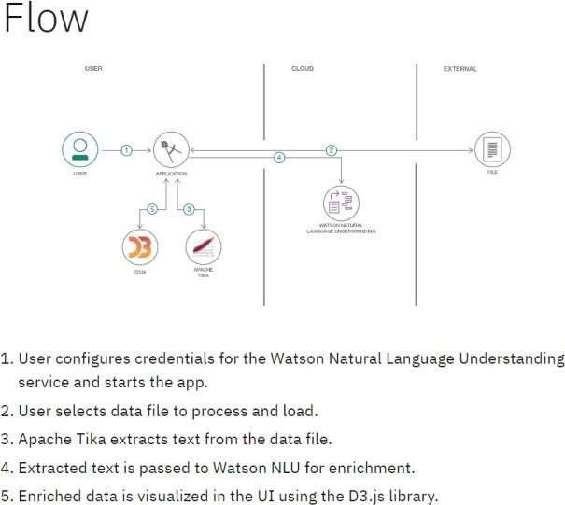

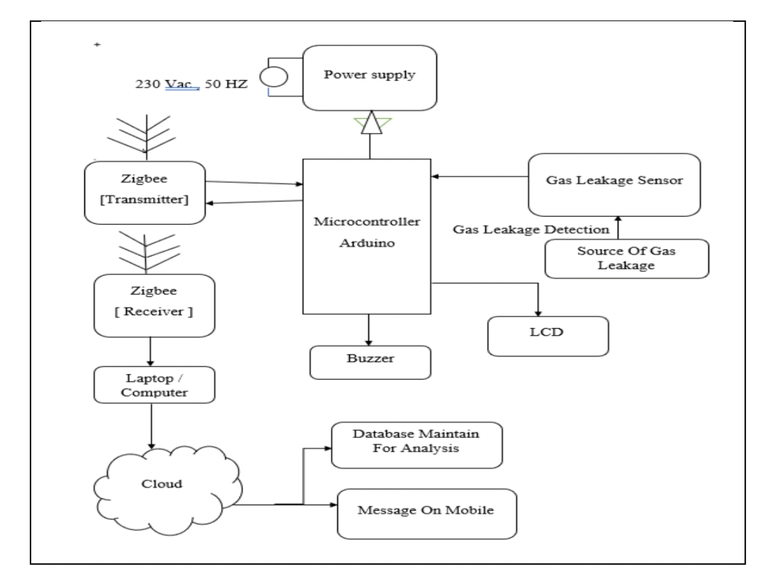

# User Stories

Use the below template to list all the user stories for the product.

**User Type**

**Functional Requirement (Epic)**

**User Story Number**

**User Story / Task**

**Acceptance criteria**

**Priority**

**Release**

Worker in industry

Owner in industry

Owner in industry

Worker in industry

Worker in industry

Gas detection design coverage

Leak detection

Gas detection actions

Gas detection location

Gas detection levels

USN-1

USN-2

USN-3

USN-4

USN-5

Area Coverage for Gas Detectors Like smoke detectors, a gas detector is capable of providing up to 75SQM area coverage based on a 5M radius of operation.

In industrial settings leak detection is a routine procedure that is necessary for monitoring product movement.

A gas detection system is usually connected with an alarm system, so as soon as the potentially dangerous gas is detected, the alarm is set to ON automatically, which warns the workers in time to safely evacuate.

A gas detection sensors should be located near the floor for gases or vapors three or four times heavier than air. They should be installed near the ceiling or roof to detect lighter-than-air gases.

A gas detection levels programmed, typically 10-20% LEL for a first alarm (warning) and 20-40% LEL for a second stage alarm to evacuate or take further action

Design coverage measures the percentage of test cases coverage against the number of requirements

To detect leaks in fluid system such as piping network and pressure vessels Gas detection systems are used to monitor and either alarm or be part of processing control

To detect install your natural gas detectors in locations close to sources of natural gas.

Gas detection level shows the percentage within a safety range of 0-10% of the Lower Explosive Limit (LEL) and, ideally, should read 0%

High

High

Low

Medium

High

Sprint-1

Sprint-1

Sprint-2

Sprint-1

Sprint-1

Worker in industry

Gas detection

USN-6

A gas detection calibration must be traceable to a Calibration is

High

Sprint-1

calibration

national or international standard in order to be considered accurate for calibration.

recommended annually or if bump testing indicates an out of spec sensor